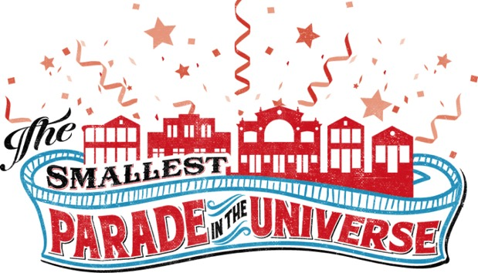
Because we all love a parade!
SIXTH ANNUAL ENTRANT APPLICATION
2020 THEME:
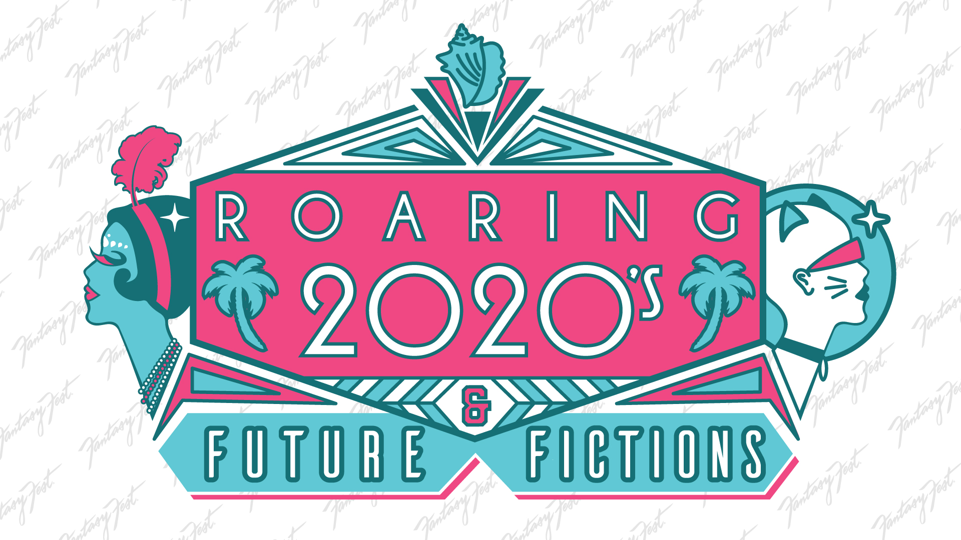
7 to 9 pm, Saturday, October 24, 2020
LIVESTREAMED FROM The Studios of Key West

The Sixth Annual Smallest Parade in the Universe at the Studios of Key West is an Imagination-on-Steroids PG 13 creative float design event—and the parade that we need now! Build a float of any media within the size limitations and compete for a $1000 first prize, $500 second prize and $250 third prize AND COMPLIMENTARY FLOAT ENTRY into the 2021 Fantasy Fest Parade! The parade will take place in front of a “Duval Street” Interpretation backdrop created by Rick Worth. Livestreamed around the world via FantastyFest.com, MARCHOUSE.org, and TSKW.org
ALL FLOATS WILL BE AUCTIONED OFF AS A FUNDRAISER TO BENEFIT THE MONROE ASSOCIATION FOR REMARCABLE CITIZENS (MARC, Inc.). A not for profit providing life services for Monroe County’s adult developmentally and intellectually disabled residents.
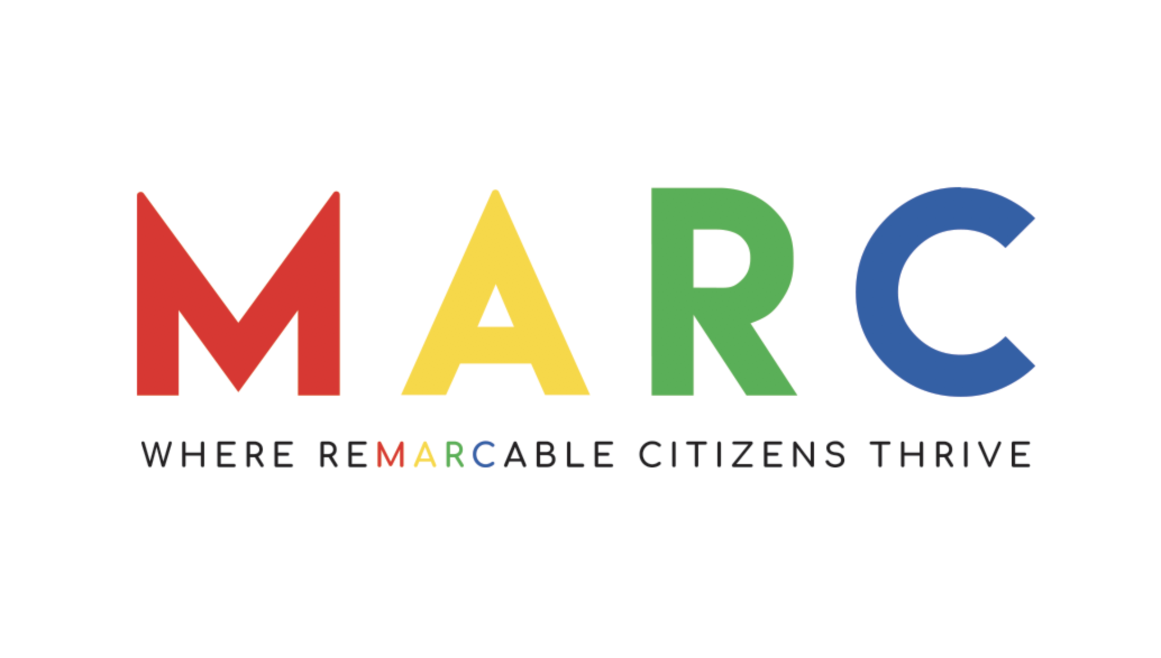

Thank you to Fantasy Fest for allowing the use of this year’s theme!
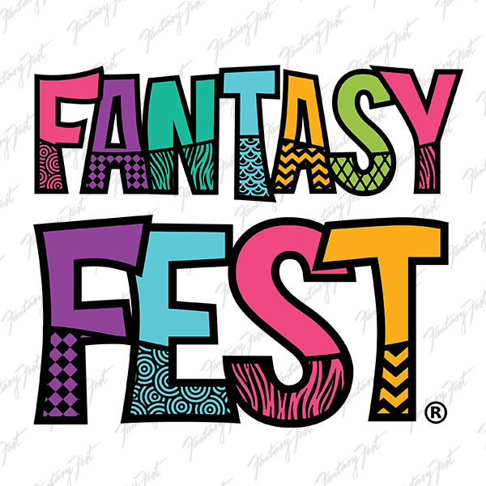

Rules: This is a PG-13 rated event. Think Fun and Funny

• Float dimensions: No larger than 18 inches long, 18 inches wide or 18 inches high.

• No means of propulsion needed. The floats will move down the parade route on a moving track. They move from right to left, so the right, starboard, “passenger” side of the float is the back and the “driver’s” side faces the audience.

• Lights and animated elements may be added to the float as long as it is done safely and totally within the dimensions. Please route all switches to the back of your entry and include a tech note for parade staff.

• Floats will be carried by parade staff to the conveyor and then to the silent auction or pick-up area. Make it easy for them by making the floats carry-friendly. Consider weight, loose parts, and wiggly things. Handles are nice.

• Sign your float with your name, its title and the year.

• No open flames, live animals, uncontained liquids, politics, blatant advertising or hazardous materials, please.

OUT OF TOWN DELIVERY: If you are sending a float from the real world, pack it carefully and address it to The Smallest Parade in the Universe, Attn: Becki Balcer, MARC Plant Store, 1401 Seminary Street, Key West, FL 33040. Schedule its arrival for October 17 through 21 and email your name and phone number and application to Becki.Balcer@gmail.com
When you ship it. Include a copy of your application in the package too.

KEEP THIS PAGE FOR YOUR REFERENCE

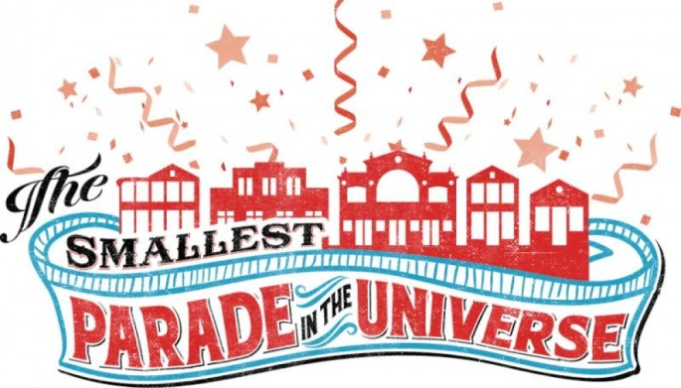

2020 SMALLEST PARADE IN THE UNIVERSE APPLICATION

GENERAL RELEASE: The undersigned does hereby forever discharge, release and hold harmless the Studios of Key West, Fantasy Fest and MARC, Inc. from all manner of actions, suits, damages or claims whatsoever from any loss or damage to the property of the undersigned while in the possession or supervision of The Smallest Parade in the Universe, Fantasy Fest and The Studios of Key West, their agents, representatives or employees, and hereby consents to abide by the rules of the event.
Please NOTE: Communications will come through email. Please check your email regularly for important updates, delivery information and/or changes.

YOUR INFO

PLEASE PRINT CLEARLY OR TYPE YOUR APPLICATION!

Group (if applicable) ______________________________________________________________________________

Entry Title __________________________________________________________________________________________

Contact Person _____________________________________________________________________________________

Email:___________________________________________________Phone______________________________________

Snail Mail: ___________________________________________________________________________________________

Description of Your Float for our fabulous announcers:_________________________________________________________________________________________________
________________________________________________________________________________________________________________
________________________________________________________________________________________________________________________________________________________________________________________________________________________________________________________________________________________________________________________________________________________________________________________________________________________________________________________________

Check here if your entry will have: 1. Animated objects ☐ 2. Music or Sound Effects ☐
3. Lights ☐

