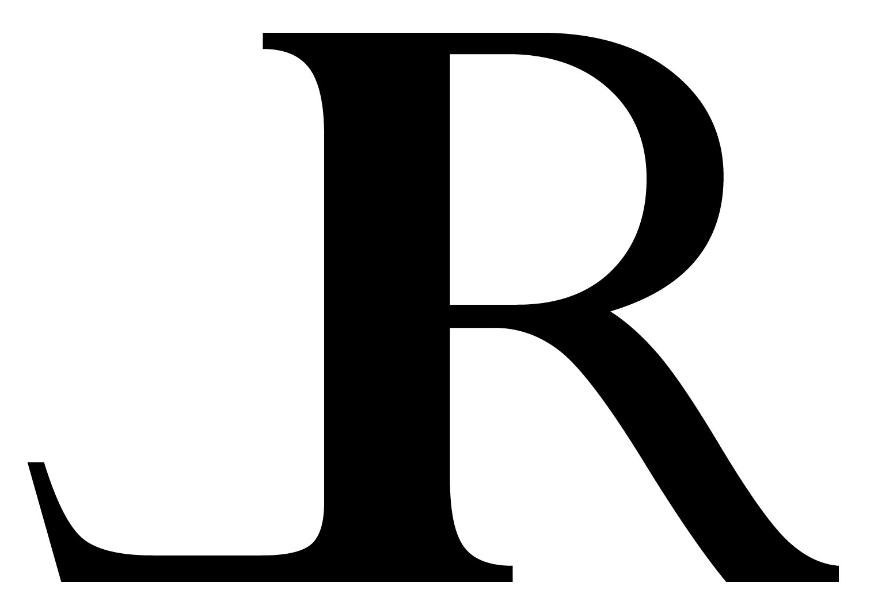
Lauren Amalia Redding
32-34 33rd Street, Apt. 1F
Astoria, New York 11106
917.485.2034 | www.laurenredding.com | lauren.amalia.redding@gmail.com
_____________________________________________________________________________________________

MATERIALS LIST: DRAWING & PORTRAITURE with LAUREN AMALIA REDDING

Please note: the materials needed for this workshop aren’t too specific. Concepts of structure, human anatomy, and proportion will be covered and can be explored with basically any dry media. While the focus of the workshop is drawing, there is no huge need to hone in on specific materials.

I. Support
A. Any smooth paper such as a Strathmore Bristol paper pad
1. Around 11 x 14” in size would be fine, but any medium-sized pad or large sketchbook will do
2. At minimum a few sheets, but a pad is fine
B. Drawing board and means of adhering paper to it
II. Tools
A. Graphite pencils
1. In range such as from 2HHB2B
2. Good kneaded eraser
B. Please, no:
1. Vine charcoal
2. Wet media such as pen and ink
III. If possible, a model
A. For my own demonstrations:
1. For a portrait demo
2. For a figure drawing demo
B. For the students:
1. For an informal portrait drawing
2. For figure drawing exercises

