Materials for Ink drawing class
Three Wednesdays in April Judi Bradford

1.
or 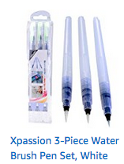 $13 or $9

2. 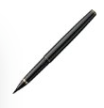 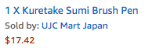

3. 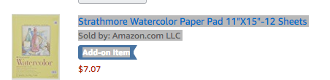

4. 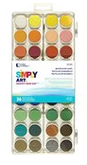 $6.65

or

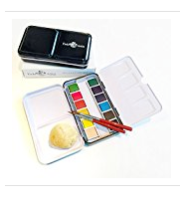 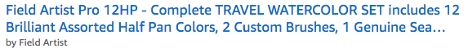$29.99

or

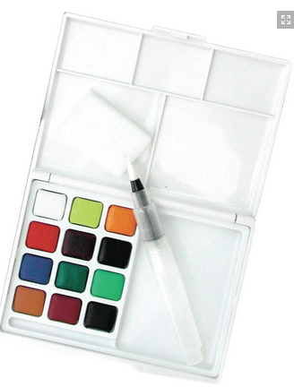 $16.62
(Utrecht)

Total $40.42 to $67

